Chapter 3 Programming
CS3000
Rebekah Jensen
rand_int
I used this method to generate two random integers to use in the rest of my program. I was confused why I had to use random.randint(1,10**n-1), but after looking into it I learned the -1 give me the largest number with n digits.

mult_int
This method is supposed to simply multiply my two random ints, so I returned n1*n2.

divis_int
This method is supposed to divide my two random ints, but I wanted to ensure that n1 couldn’t be divided by 0, as that would result in undefined. If n2 does not equal 0, then my code returns the product of n1/n2. Else, it will return infinity, which I learned about in my last programming assignment (Ch. 2).

I initially had two functions to measure my time, like mult_time_rec and divis_time_rec, but as explained below, I was having issues with this so decided to just make one measure_time function. I left that code out and commented it out in case I want to look back on it.

measure_time
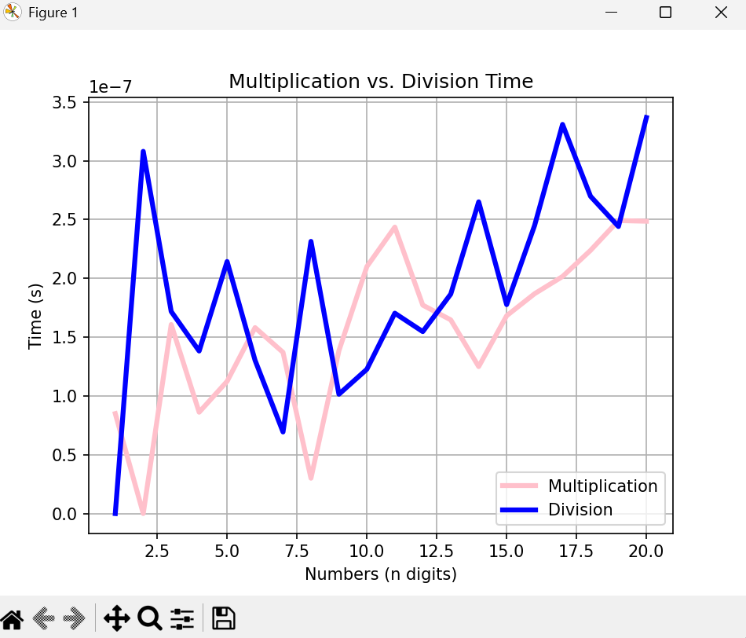
I had a lot of trouble getting my graph to work the way it was supposed to. The graph often pulled up but without any of my lines or just one horizontal line. It took a while to figure out how to fix this, but after adding a debugging print line to my “f n in range” method, I learned that while n integers were changing and working, my record time methods were not working. I think it’s because I had mistakes in my measure_time function. After looking into it, I added an iterations variable to loop my mult_int and divis_int functions 100,000 times to actually see it illustrated on the graph. I think my original attempt wasnt working because the multiplication and vision operations are too fast, which kept leading me to 0.0 time for both functions. I’m glad I was finally able to make it work after many attempts to fix my code.

Plotting
This was my first time using matplotlib. I love seeing the results of my program visually, so I was a fan of this.

